Visvesvaraya Technological University, Belagavi – 590010



DBMS MINI PROJECT REPORT

ON

**FOOTBALL PLAYER MANAGEMENT SYSTEM**

***Submitted by***

Vivian D’Souza 4SO20AI060

Wilson Aranha 4SO20AI061

**Under the guidance of**

**Ms Renuka Tantry**

(Assistant Professor, ICBS Department)



**DEPARTMENT OF ARTIFICIAL INTELLIGENCE & MACHINE LEARNING**

**ST JOSEPH ENGINEERING COLLEGE**

**Vamanjoor, Mangaluru -575028, Karnataka**

**2022-2023**

**ST JOSEPH ENGINEERING COLLEGE**

**Vamanjoor, Mangaluru- 575 028**

**DEPARTMENT OF ARTIFICIAL INTELLIGENCE & MACHINE LEARNING**



#### CERTIFICATE

*This is to certify that the Mini project entitled* ***“Football player management system”*** *is a bonafide work carried out by*

*Vivian D’Souza 4SO20AI060*

*Wilson Aranha 4SO20AI061*

*Students of fifth semester B.E. Artificial Intelligence & Machine Learning, and submitted as a part of the course DBMS Laboratory with Mini Project (18CSL58), during the academic year 2022-2023.*

**----------------------------- -----------------------------------**

**Ms Renuka Tantry Dr Shreenath Acharya Project Guide Head of the Department**

**Name of the Examiners Signature with Date**

1. -------------------------- 1. -------------------------

2. ------------------------- 2. --------------------------

**Abstract**

This report describes the implementation of a Database Management System for Football players management system. It was developed to view top players and create a team using these players.

This report mainly includes the background and development process of the project. The main steps in the development process are identifying the Entities and the Relationship among them and presenting them in graphical form with an ER Diagram. It also includes some of the SQL queries used in the implementation of the MySQL Database.

**ACKNOWLEDGEMENT**

We dedicate this page to acknowledge and thank those responsible for shaping the project. Without their guidance and help, the experience while constructing the dissertation would not have been so smooth and efficient.

We sincerely thank **Ms. Renuka Tantry, Assistant Professor**, Department of Intelligent Computing & Business Systems for her guidance and valuable suggestions which helped us to complete the project.

We owe our profound gratitude **to Dr. Shreenath Acharya, Head of the Department**, of Intelligent Computing Business Systems, whose kind consent and guidance helped us to complete this work successfully.

We are extremely thankful to our **Director**, **Rev. Fr Wilfred Prakash D’Souza**, our **Principal**, **Dr. Rio D’Souza, and our Assistant Director, Rev. Fr Alwyn Richard D’Souza** for their support and encouragement.

We would like to thank all our ICBS Faculty and Staff members who have always been with us extending their support, precious suggestions, guidance, and encouragement in all possible ways.

We also extend our gratitude to our friends and family members for their continuous support.

**LIST OF TABLES AND FIGURES**

1. ER Diagram .................................................................................................................

2. Schema Diagram..........................................................................................................

3. User table......................................................................................................................

4. Manager table...............................................................................................................

5. Club table......................................................................................................................

6. Club formation table....................................................................................................

7. Player table....................................................................................................................

8. Fig4.1-Home Page......................................................................................................

9. Fig 4.2-Login Page......................................................................................................

10. Fig 4.3-Register Page.................................................................................................

11. Fig 4.4-Manager Page.................................................................................................

12. Fig 4.5-Formation Page...............................................................................................

13. Fig 4.6-Player Page.....................................................................................................

14. Fig 4.7-Formation With Player Page.........................................................................

**TABLE OF CONTENTS**

Abstract............................................................................................................................

Acknowledgment.............................................................................................................

Table of Contents.............................................................................................................

Chapter 1 -Introduction...................................................................................................

* 1. Problem Definition................................................................................................
  2. Scope and Importance..........................................................................................

Chapter 2-Software Requirement Specification...........................................................

2.1 Functional Requirement Specification................................................................

2.2 Software Requirement Specification..................................................................

2.3 Hardware Requirement Specification.................................................................

Chapter 3 – Design..........................................................................................................

3.1 ER Diagram...........................................................................................................

3.2 Schema Diagram...................................................................................................

3.3 Table Description..................................................................................................

Chapter 4-Screenshots.....................................................................................................

Chapter 5 – Conclusion and Future Work....................................................................

References........................................................................................................................

**CHAPTER 1-INTRODUCTION**

* 1. **PROBLEM DEFINITION**

Managing players across the world is really a huge task as there are thousands of leagues, clubs, and millions of football players. It becomes hard for the user to keep track of all of the players of the world. Football player management system allows users to view the top players, create their own manager, and formation and select the players they want in their team. And have a final formation of 11 top players that the user wanted to see together.

* 1. **SCOPE AND IMPORTANCE**

• A Football Player Management System is a software tool used to manage and organize a team's players.

• Users can see the stats of top players across the world.

• This system considers the form and ability of the players and sets some rating for each individual player so that users can have a better understanding of which player to pick.

• It enables the users to view their final formation which can be used to compare with friends to see who has the best team.

**Chapter 2-Software Requirement Specification**

**2.1 Functional Requirement Specification**

Functional requirements define the fundamental actions that must take place in the software. They specify which outputs should be produced from the given output. They describe the relationship between the input and output of the system. The user interface provides communication between the user and the system and our application also has communication between them. The various functions provided by the system are listed below.

**2.1.1 Generic View**: This is the most basic feature which can be accessed by any kind of user whether registered or unregistered news. The user gets to see only the front page.

**2.1.2 Registration**: A user who wishes to create his account may use this and the following is the list of actions that take place

• **Input** - First Name, Email Id, and Password

• **Process** - After entering the required details, the system validates the details whether the entered data is correct or not.

• **Output** - An account is created and users can log in at any time.

**2.2.3 Login**: This module is provided for users such as stock buyers who have registered themselves in the system.

• **Input** - Email Id and Password

• **Process** - After entering the email id and password, the process of validation occurs to identify whether the required details are present in the database or not.

**2.2 Software Requirement:**

• IDE-VS Code

• Web browser

• NodeJs

• MySQL Version 5.5 or above

• Operating System: Any (Linux, Windows, Mac, etc.)

**2.3 Hardware Requirement Specification**

• **Processor** - Intel Core i3 or above

• **RAM** - 2 GB or more

• **Hard** **Disk** - 64 GB or more

• **Monitor** - VGA of 1024x768 screen resolution

• Keyboard and Mouse

**CHAPTER 3-DESIGN**

**3.1 ER Diagram**

**3.2 Schema Diagram**

**3.3 Table Description**

**CHAPTER 4-SCREENSHOTS**

**4.1 HOME PAGE**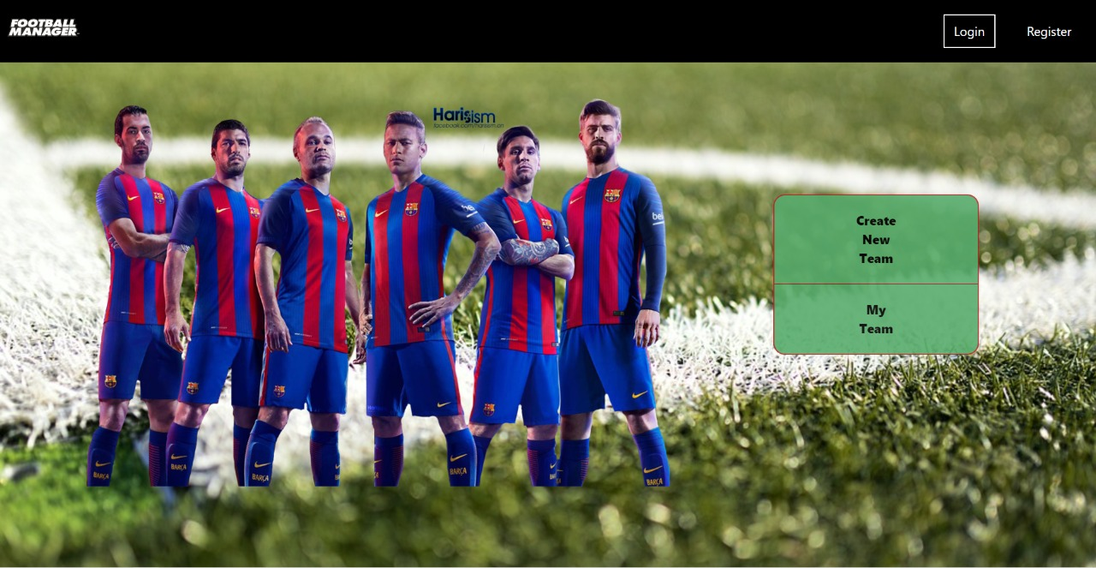

**4.2 LOGIN PAGE**

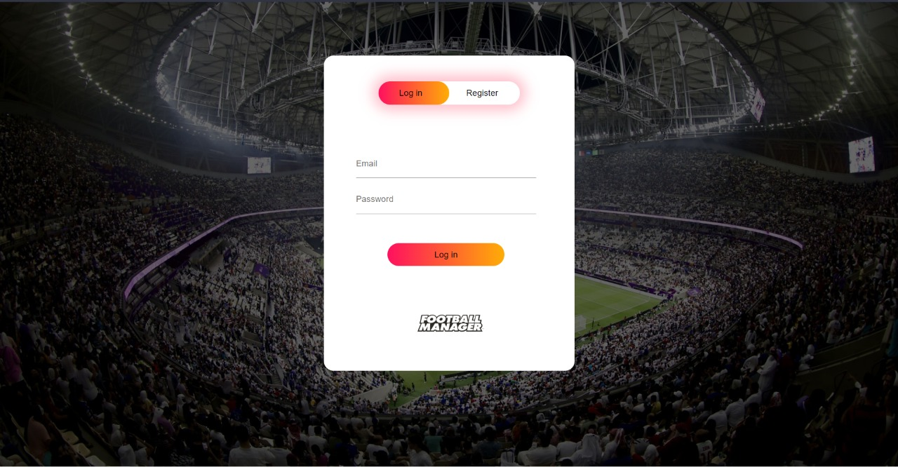

**4.3 REGISTER PAGE**

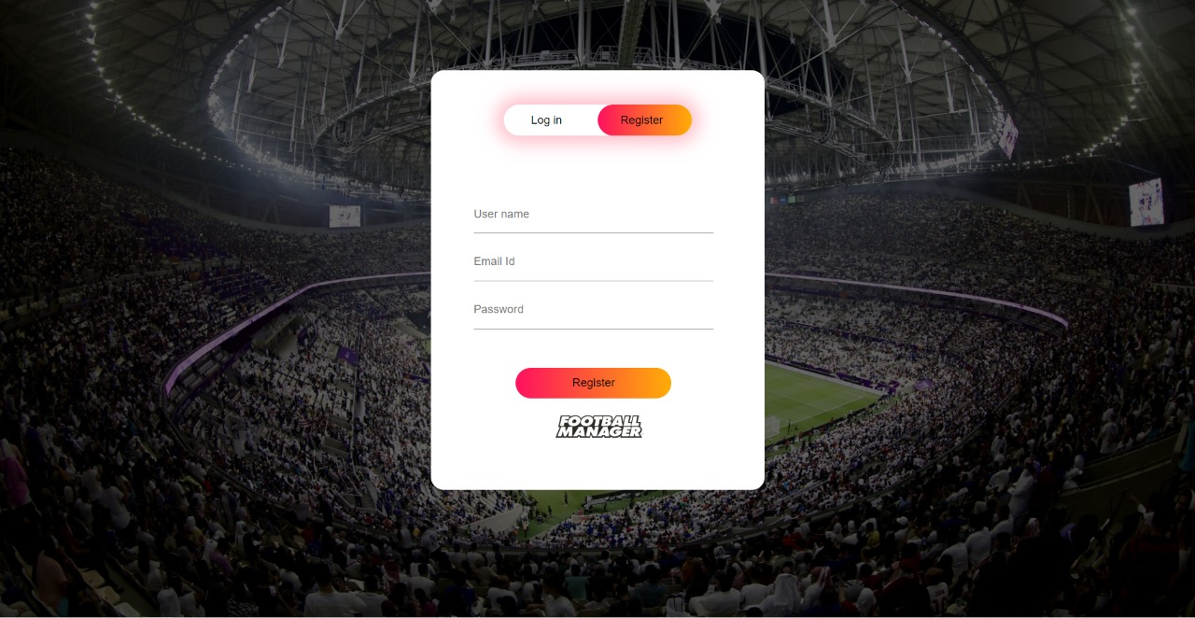

**4.4 MANAGER PAGE**

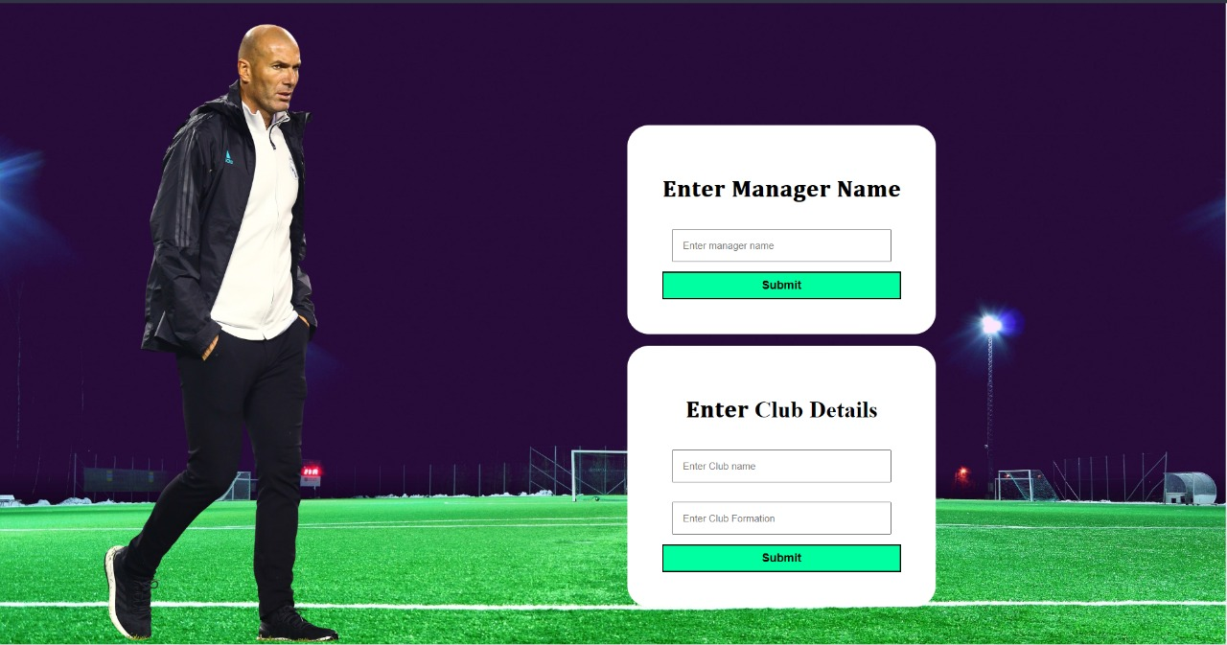

**4.5 FORMATION PAGE**

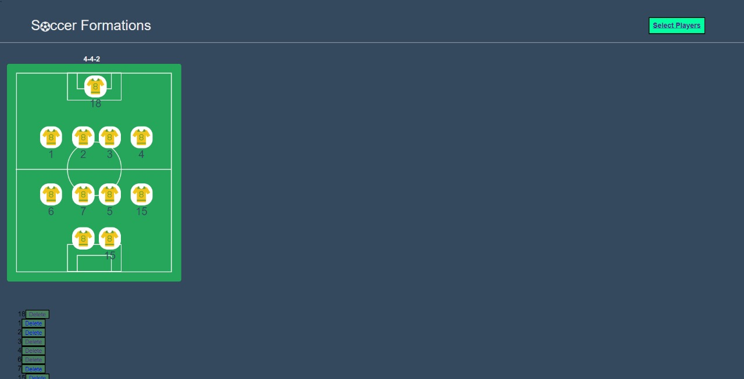

**4.6 PLAYER PAGE**

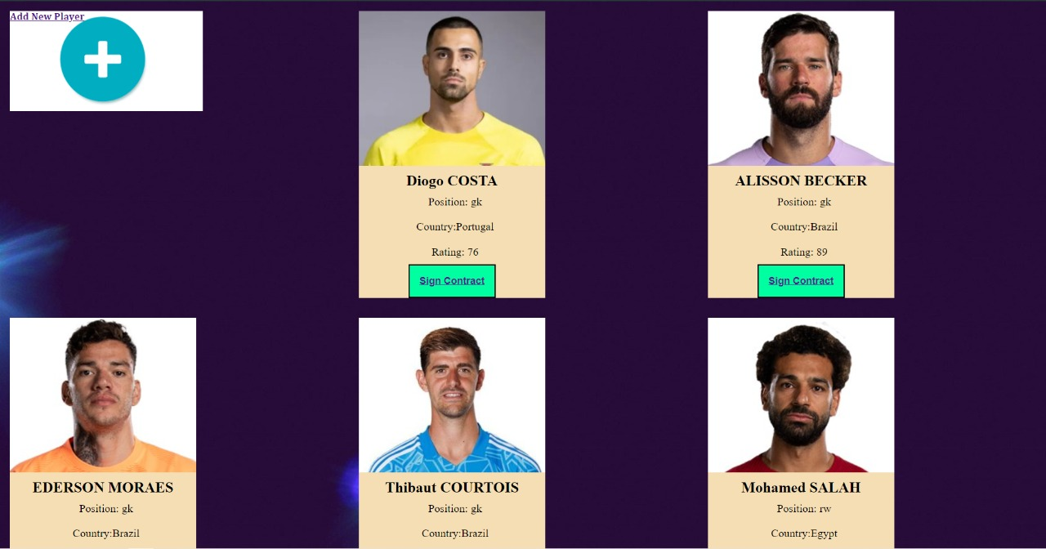

**4.7 FORMATION WITH PLAYER PAGE**

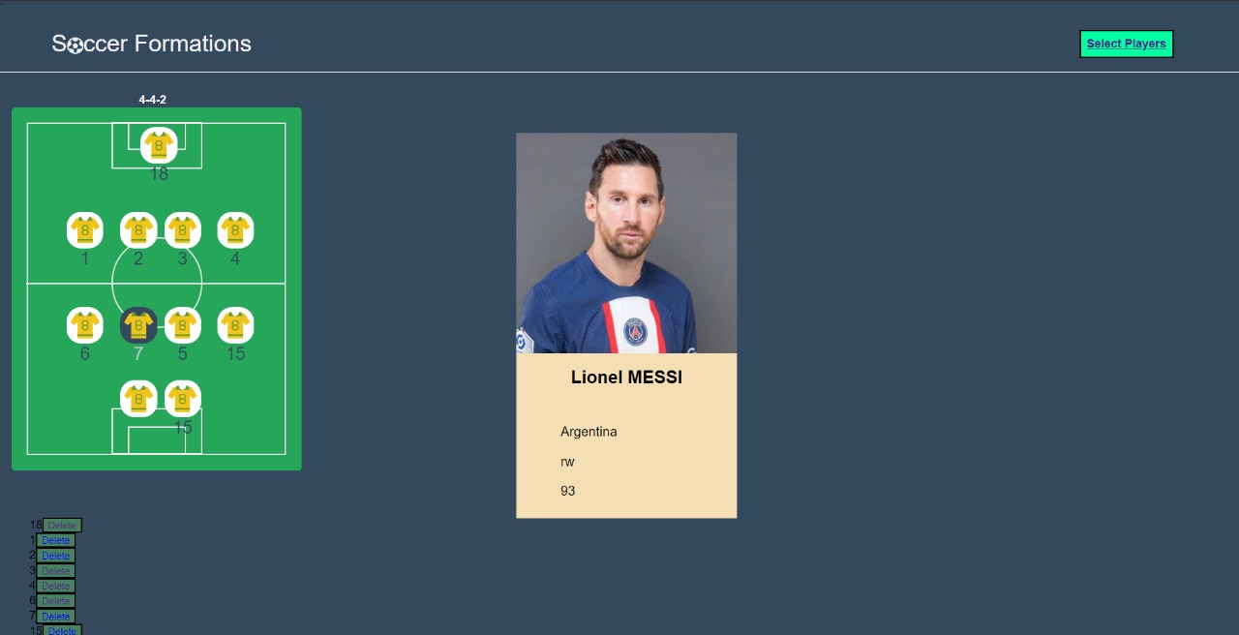

**CHAPTER 5-CONCLUSION AND FUTURE WORK**

A Football Player Management System is a software tool used to manage and organize a team's players. It allows Users can see the stats of top players across the world. This system considers the form and ability of the players and sets some rating for each individual player so that users can have a better understanding of which player to pick. It enables the users to view their final formation which can be used to compare with friends to see who has the best team.

For future work, Football Player Management Systems could be further developed to include more advanced analytics and data visualization tools to help managers make more informed decisions. Creating custom leagues for list of users and creating fixtures and simulate the match between them. The features like sending the football related notification updates to the users using their registered mobile numbers to their telegram and WhatsApp is the scope we can expand beyond the objective of this project

Top of Form